**T+1 Steering Committee (T1SC)**

**Meeting Information**

**Join Zoom Meeting**

**https://us02web.zoom.us/j/83350749421?pwd=YlBoSkRiSFg1Y21WQmt1RGVZRWlBUT09**

**Meeting ID: 833 5074 9421**

**Passcode: 4CZCsF**

**One tap mobile**

**+17789072071,,83350749421#,,,,*410691# Canada**

**+12042727920,,83350749421#,,,,*410691# Canada**

**Dial by your location**

**+1 778 907 2071 Canada**

**+1 204 272 7920 Canada**

**+1 438 809 7799 Canada**

**+1 587 328 1099 Canada**

**+1 647 374 4685 Canada**

**+1 647 558 0588 Canada**

**Meeting ID: 833 5074 9421**

**Passcode: 410691**

**Find your local number: https://us02web.zoom.us/u/k3z8RXieb**

**T+1 Steering Committee (T1SC)**

**April 23, 2024 at 11:00 AM ET**

**Agenda**

**Co-Chaired by:**

Jason O’Born – RBC

Keith Evans – CCMA

1. Approval of Minutes from the meeting held on March 26, 2024, 2024
2. General Industry Update
   1. Mexico – update (attached)
   2. Project Acknowledgement Forms - update
3. Working Group Reports
   1. Operations - Sheera Badial and Domenic Sgambelluri
      1. OWG Update
      2. ETF Taskforce – update (attached)
      3. OWG-033 NI 62-104 – Issuer Bids. Draft CSA Letter for approval.(attached)
      4. Issue Logs to be closed (attached)
         1. OWG-020 FX I
         2. OWG-038 Transition Weekend Issues
         3. OWG-022 Ex-Date processing during the transitional period
   2. Legal/Regulatory - Jamie Anderson
      1. LRWG Update
      2. Issue Logs to be closed (attached)
         1. T1LRWG-2 – NI 62-104 Takeover Bids and Issuer Bids
         2. T1LRWG-4 – NI 81-102 Investment Funds
         3. T1LRWG-9 – Inv. Funds - Prospectuses, Offering Memo. & contracts
         4. T1LRWG-14 – Scholarship or Education Plans
         5. T1LRWG-15 – (MFD 5.4.3) - Settlement Date on Trade Confirmations
         6. T1LRWG-22 – CDCC
         7. T1LRWG-30 – TSX Rule Book
         8. T1LRWG-31 – TSX Company Manual
         9. T1LRWG-32 – Bourse de Montréal Inc.
         10. T1LRWG-33 – TSX Venture Exchange Rule Book
         11. T1LRWG-55 – EquiLend Canada Corp.
         12. T1LRWG-78 – EquiLend LLC
   3. Mutual Funds - James Stares and Rosemary Marchesano
      1. MFWG Update
   4. Education/Communications - Barb Amsden
      1. CEWG Update
      2. T+1 Readiness Survey results -update
4. Other Business
5. Next Meeting TBD

**T1SC - Minutes of March 26, 2024**

Keith Evans of CCMA welcomed attendees to the T+1 Steering Committee meeting.

**1 - Approval of the Minutes from the meeting held on February 27, 2024**

Keith reported that the Minutes from the last T+1 Steering Committee meeting, held on February 27, 2024, were distributed with the meeting package. There were no additions, subtractions or material corrections requested by members, therefore the Minutes of the meeting were approved as presented.

**2 - General industry update**

Keith Evans provided a general update on a few T+1 related items as follows:

* There are 62 days until implementation date.
* Keith said that Argentina still intendeds to transition to T+1 on May 27th, but could not confirm regulatory approval.
* Keith then reported that in the Sifma Newsletter this morning, an article from DTCC reports that the confirmation rates are slowing in the US, as of February.
* He said that ESMA produced a document last week that was quite negative towards the move to T+1. Consequently, they will not decide until after they review how US/Canada goes. This will result in an implementation to T+1 that won’t likely happen until 2027.

**3 - Working Group Reports**

Keith Evans asked the chairs of each of the working groups to provide a quick update on their respective working groups’ activities.

**A - Operations**: Domenic Sgambelluri reported on the last meeting of the OWG, where members discussed the following

* CDS and CDCC testing is going well.
* CALSA (Phil Zywot) reported that Securities Lending has made considerable progress on the CDS Recall Hub, supporting the recall of loaned securities.
* CDS indicated that they are in discussions with TELUS and Computershare on possible improvements to the handling of deposit/withdrawal for the monitoring of foreign ownership.
* CDS Risk provided an update on the impact of T+1. CDS has indicated that for collateral pool resizing, RAC and SDRC at CDS have submitted modifications to the Bank of Canada for consideration.
* At the request of Domenic, Jamie Anderson reported on the progress of the ETF collateral letter destined for the OSC. He said that the letter had been previously submitted and approved by the Steering Committee last month. However, after submitting the letter to the OSC, a request was made to amend the letter to include a legal analysis. Jamie said that the revised letter which was attached to the meeting package for today’s meeting detailed the new information. He summarized the changes, which identified why the need for regulatory guidance was needed. Jamie reported that the OWG recommended that in order to expedite the overall process, it is recommended that the submission would go to the OSC only, instead of the full CSA……**The CCMA T+1 Steering Committee members unanimously approved the submission of this updated letter.**
* At the request of Domenic, Keith provided a summary on the proposed Project Acknowledgement Form (PAF). The form is identical to that which we used during the transition to T+2 in 2017. Keith mentioned that this is not legally binding, but provides comfort to the overall industry on our readiness. He also referred to the list of entities to which CCMA would ask to sign the PAF on or before April 26, 2024. It was pointed out that Equilend has ceased to be an ATS (March 20, 2024) and should be removed from the list of ATS...……**The CCMA T+1 Steering Committee members unanimously approved both the Project Acknowledgement Form, as well as the distribution list, with the noted edits.**

**B - LRWG**: Jamie Anderson reported on the last meeting of the LRWG, where members discussed the following

* Jamie summarized the current status of the outstanding ‘Action Items’.
* Jamie reported that Issue Log LRWG-48 SS&C is being presented for closure, since SS&C had resigned their MSU status in Ontario in 2022….**The CCMA T+1 Steering Committee members unanimously approved the closure of LRWG-48 SS&C.**
* NI 62-104 which deals with Takeover Bids. It was previously agreed that CCMA would draft a letter to the CSA to reduce the settlement period to align with the standard settlement cycle as well as align with the US. Jamie reported that this will be prepared for review at next month’s meeting of the OWG as well as the Steering Committee.

**C - Mutual Funds:** Rosemary Marchesano fromFundserv reported the following.

* All industry testing has been completed without any issues
* In addition, Fundserv has a survey out there asking manufactures if they plan on moving ‘some’ ‘none’ or ‘all’ of their funds to T+1.
* Keith said that CCMA had met with the heads of Fundserv and IFIC, looking for assistance in communicating to the manufactures and getting them to identify which funds will transition to T+1 in May. He reported that Fundserv mentioned that of the 92,000 funds currently settling on a T+2 basis today, 62% have indicated that they will move to T+1.
* A question was asked Barb agreed that CCMA is working on getting greater clarity/reason on Funds that are not going to move to T+1.
* Fundserv provided the following chart to clarify the status of T+1 information.
* 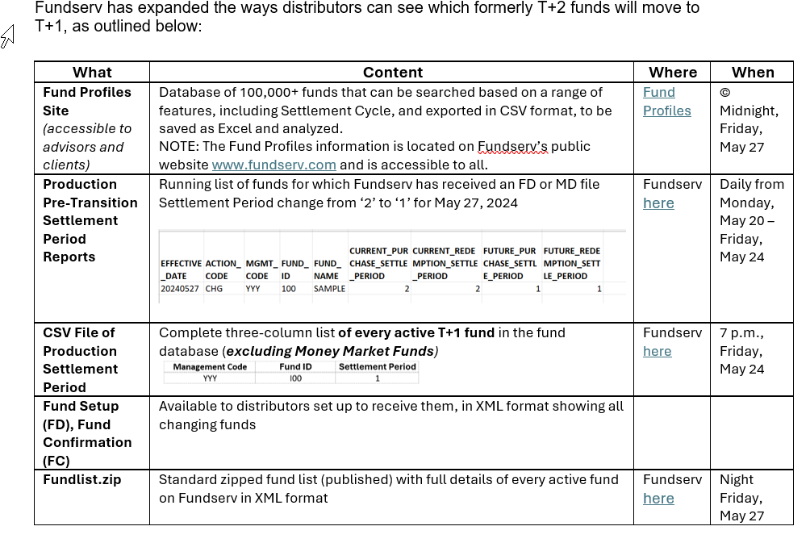

**D – Communication/Education:** Barb Amsden reported that the CEWG is working on the following:

* The most recent Newsletter will be out on early next week.
* CEWG is working on Advisor and client facing material. Documentation that they could use to communicate with their customers.
* Barb asked all member to complete the T+1 readiness survey this week.
* There have been some questions on swaps that will be finalized shortly.
* Barb reported on the Transitional Support Plan, which was included in the meeting package. CCMA will host a daily call for communicating the latest information with regards as to how the transition is going. This will be a chance for members to share comments, issues and questions and get answers as quickly as possible. The Minutes will be posted on the CCMA website shortly after the call. The calls will start the week leading up to transition, through transition weekend and the first full week of transition.
* Keith asked for the best time for these call to take place. It was agreed that 10 AM ET would be preferred, but more could be added as needed. Keith agreed to set up these meeting for everyone on the Steering Committee in the next week or so.

**4 – Other Business**:

* Members discussed which settlement date applies to transactions under various scenarios both domestically as well as between entities in different jurisdictions. It was agreed that Traders can also override the standard settlement cycle, but generally the settlement standard for the jurisdiction in which the trade was executed would be the settlement date for that trade…..irrespective of where the underlying asset ‘usually’ trades.
* Barb Amsden reported on a document that will soon be posted on the CCMA website. However, before that can happen, members are requested to review for completeness. The document outlines Sifma/ISDA and CCMA perspectives on derivatives in T+1, and if swaps will follow the underlying security website. Comments are expected by Friday April 5, 2024.

**5 – Next Meeting:** The next meeting of the T+1 Steering Committee is scheduled for Tuesday April 23, 2024 at 11:00 AM ET.

**Attendees**

|  |  |  |  |  |  |  |  |  |  |  |  |  |  |  |  |  |  |  |  |  |  |  |  |  |  |  |  |  |  |  |  |  |  |  |  |  |  |  |  |  |  |  |  |  |  |  |  |  |  |  |  |  |  |  |  |  |  |  |  |  |  |  |  |  |  |  |  |  |  |  |
| --- | --- | --- | --- | --- | --- | --- | --- | --- | --- | --- | --- | --- | --- | --- | --- | --- | --- | --- | --- | --- | --- | --- | --- | --- | --- | --- | --- | --- | --- | --- | --- | --- | --- | --- | --- | --- | --- | --- | --- | --- | --- | --- | --- | --- | --- | --- | --- | --- | --- | --- | --- | --- | --- | --- | --- | --- | --- | --- | --- | --- | --- | --- | --- | --- | --- | --- | --- | --- | --- | --- |
| |  | | --- | | Arjun | | Art Valdes | | Assane Ndoye - Desjardins | | Attila Branyiczky (BMO) | | Barb Amsden, CCMA Chair - CEWG | | BGrossman CIRO | | Bill Devolin - Manulife | | Brent Blake | | CANDIR | | Carol Revoredo - CIBC Mellon | | Cathrine Drennan - CIRO | | Christos Ekonomidis - BNYM | | Dan Brennan | | Danny Leca CIBC | | David O'Marra | | David Petiteville @rbc | | Deepak Datt | | den8351 | | Dom Sgambelluri - Co Chair OWG | | Doug Gifford | | Francis Coche AMF | | Franklin Lacroce OSC | | Halyna | | Keri Peacock - BMO | | James Stares | | Jamie Anderson CCMA Chair - LRWG | | Jason Dear @ BNS | | **Jason O'Born Co-Chair T1SC** | | jdufrene | | Johann Lochner | | Judith Marcelo | | Kamol Mavlyanov | | **Keith Evans - CCMA Co-Chair T1SC** | | Kevin Calhoun TD | | Kevin Duncan | | Louis Lesnika - CIBC Mellon | | Luisa R | | Lyndon James | | Marcus Barrett | | Mark Cicero - BMO | | Martin Palivec - Citi | | Mary Beth Law | | Matthew Andreacchi (OSC) | | Meaghan Li | | Mei Yang- Citi (Mei Yang) | | Michael G. - BMO | | Michael Klinov | | Michael Lowes - TD Securities | | Michael Palmiotto | | Muneeb Ahsan - CIRO | | Nathalie Picard | | Nav Badhan - BNYM | | Nelson Dugré-Sasseville - NBC | | Noura Dube | | Olga Svistoun - BMO | | Pamela Egger | | Pat Dunwoody | | Phil Zywot, CASLA/BNY Mellon | | Rosemary Marchisano - Fundserv Chair MFWG | | sauves | | Scotia - Hinkson | | sgodhwani | | Sheera Badial - Canaccord Co-Chair OWG | | Stef Caputo (Bank of Canada) | | Stephanie Leblanc-Mchenry | | Sun Young Sauve | | TAE5098 | | Tammy Savinkoff | | Vanguard | | Wendy Chen | |
|  |
|  |
|  |
|  |
|  |
|  |
|  |
|  |
|  |
|  |
|  |
|  |
|  |
|  |

|  |
| --- |
|  |
|  |
|  |
|  |
|  |
|  |
|  |
|  |
|  |
|  |
|  |
|  |
|  |
|  |
|  |
|  |
|  |
|  |
|  |
|  |
|  |
|  |
|  |
|  |
|  |
|  |
|  |
|  |
|  |
|  |
|  |
|  |
|  |
|  |
|  |
|  |
|  |
|  |
|  |