T+1 Steering Committee (T1SC)
Agenda
November 18, 2021 at 12:30 PM ET
- Introduction of T+1
  - T+1 Organization in Canada
  - T+1 Steering Committee DRAFT Mandate
  - T+1 Steering Committee Membership
  - T+1 Working Group DRAFT Mandates
    - Operations
    - Legal/Regulatory
    - Mutual Funds (still a work in progress)
    - Education/Communications
- CCMA Funding
- Other Business
- Next Meeting December 16, 2021

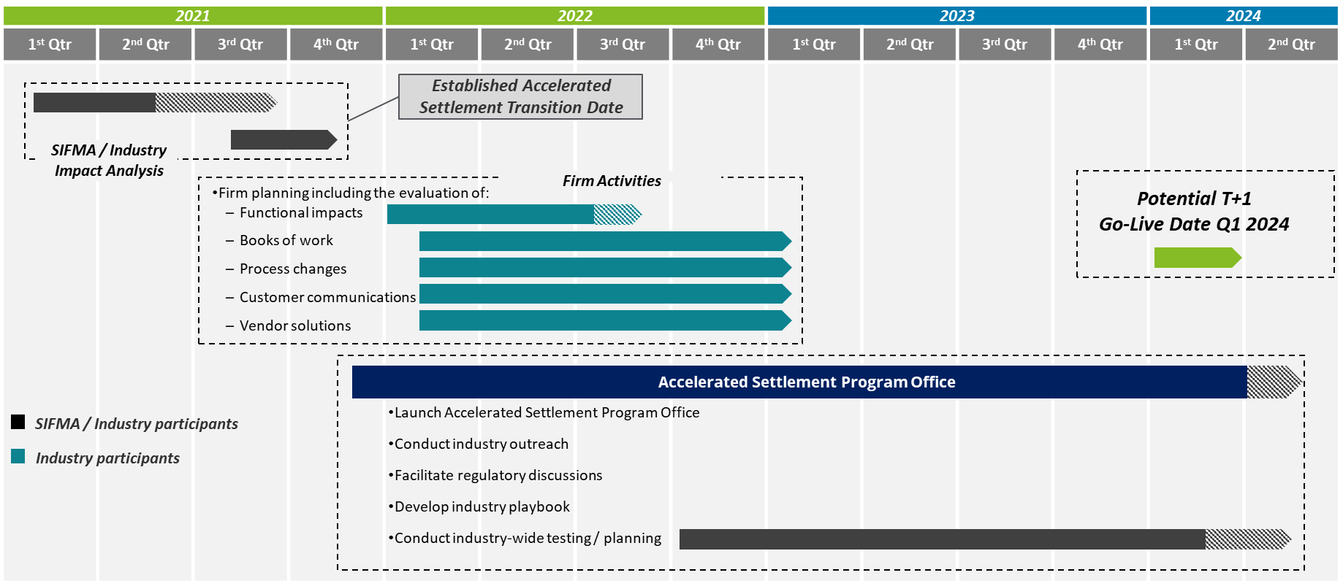

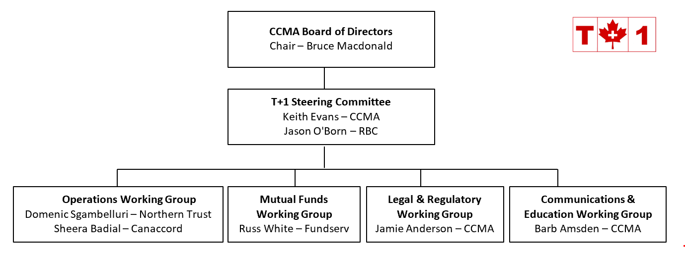

T+1 Steering Committee (T1SC)
Mandate for T+1 Initiative
Overview
The T+1 Steering Committee (“T1SC”) has been mandated to co-ordinate an industry-wide effort to shorten the securities settlement cycle from the current two day period, or T+2, to a one day period, or T+1. The T1SC will identify legal and regulatory changes, systems, processes and procedural changes, and ensure effective communication and education of the overall Canadian financial services industry.

The Canadian T+1 initiative is being coordinated in concert with the United States. The joint Canadian-American implementation date is targeted for Q4 – 2023 to Q2 - 2024.
Composition
The T1SC membership is open to individuals representing firms and organizations with an interest in the T+1 initiative. These firms and organizations include the buy-side, custodians, sell-side, service providers, industry utilities, self-regulatory organizations, and other regulatory bodies.
Reporting Structure
The T1SC reports to the CCMA Board of Directors via the Executive Director/Co-Chair of the T1SC.
Responsibilities
The T1SC will, or will oversee working groups that will:
- identify all areas (system development, procedure, process, etc.) that need to be addressed,
- identify the various solutions to the above,
- gain industry agreement on required standards,
- identify regulatory changes,
- agree on timelines,
- coordinate activities to complete the tasks,
- educate those in need of education,
- be a spokesperson for the T+1 initiative,
- plan the industrywide testing that will be needed to ensure readiness,
- coordinate with the U.S. to ensure a lock-step approach with regards to implementation.
Governance
Meetings will be called by one of the Co-Chairs. Notices calling meetings and agendas will be sent to all T1SC members/observers. Meetings will be minuted and attendance recorded. Meeting minutes will be tabled with the T1SC for approval. There is no set minimum quorum requirement for meetings. Minutes and decisions of the T1SC may be posted on the CCMA website.

Proposed T1SC Membership List
Buy Side
Mark Austin Connor, Clark and Lunn Financial Group
Katie Walmsley PMAC (Portfolio Management Association of Canada)
Pamela Egger IFIC
TBD TBD
Custodian
Louis Lesnika CIBC Mellon
Domenic Sgambelluri Northern Trust/Co-Chair OWG
John Riordon RBC Investor Services
Denny Mendonca State Street
Sell Side
Keri Peacock BMO
TBD BNS
TBD CIBC
TBD Fidelity Clearing
Nelson Dugré-Sasseville National Bank
Jason O’Born RBC Capital Markets/Co-Chair T1SC
Sheera Badial Canaccord/Co-Chair OWG
Rob Candido TD
Other
Barb Amsden CCMA/Chair CEWG
Jamie Anderson CCMA/Chair LRWG
Russ White FundServ/Chair MFWG
Keith Evans CCMA/Co-Chair T1SC

Operations Working Group (OWG)
Mandate for T+1 Initiative
Overview
The Operations Working Group (“OWG”) has been mandated to identify all operational issues/obstacles related to Canada’s move from a securities settlement period of two days (T+2) to one day (T+1).
The Canadian T+1 initiative is being coordinated in concert with the United States. The joint Canadian-American implementation date is targeted for Q1-2024.
Composition
The OWG membership is open to individuals representing firms and organizations with an interest in the T+1 initiative. These firms and organizations include the buy-side, custodians, sell-side, service providers, industry utilities, self-regulatory organizations, and regulatory bodies. New members may join the OWG at any point.
Reporting Structure
The OWG reports to the CCMA T+1 Steering Committee (“T1SC”) via the OWG Co-Chairs.
Responsibilities
The OWG will:
- identify, describe and document all operational issues including systems, processes and procedures related to the move to T+1;
- achieve industry consensus on proposed solutions, action plans and timelines for all open issues, including the determination of testing criteria/requirements;
- assign responsibility for issues;
- provide ongoing communication to the T1SC, tracking issues through to completion; and
- provide additional guidance, direction, and support for T+1 operational
issues as requested by the T1SC.
- Identify if sub-working groups will be required for specific issues

Governance
Meetings will be called by the Co-Chairs. Notices calling meetings and agendas will be sent to all OWG members. Meetings will be minuted and attendance recorded. Meeting minutes will be tabled with the OWG for approval. There is no set minimum quorum requirement for meetings. All recommendations will be forwarded to the T1SC for final approval. Minutes, decisions and issue logs of the OWG may be posted on the CCMA website.

Legal and Regulatory Working Group
(LRWG)
Mandate for T+1 Initiative

Overview
The Legal and Regulatory Working Group (“LRWG”) has been mandated to identify all legal and regulatory issues related to Canada’s move from a securities settlement period of two days (T+2) to one day (T+1).
The Canadian T+1 initiative is being coordinated in concert with the United States. The joint Canadian-American implementation date is targeted for Q1-2024.
Composition
The LRWG membership is open to individuals representing firms and organizations with an interest in the T+1 initiative. These firms and organizations include the buy-side, custodians, sell-side, service providers, industry utilities, self-regulatory organizations, and regulatory bodies. New members may join the LRWG at any point.
Reporting Structure
The LRWG reports to the CCMA T+1 Steering Committee (“T1SC”) via the LRWG Chair.
Responsibilities
The LRWG will:
- identify, describe and document all legal and regulatory issues related to the move to T+1;
- achieve industry consensus on proposed solutions, action plans and timelines for all open issues;
- assign responsibility for issues;
- provide ongoing communication to the T1SC, tracking issues through to completion; and
- provide additional guidance, direction, and support for T+1 legal and regulatory issues as requested by the T1SC.

Governance
Meetings will be called by the Chair. Notices calling meetings and agendas will be sent to all LRWG members. Meetings will be minuted and attendance recorded. Meeting minutes will be tabled with the LRWG for approval. There is no set minimum quorum requirement for meetings. All recommendations will be forwarded to the T1SC for final approval. Minutes and decisions of the LRWG may be posted on the CCMA website.

Mutual Funds Working Group (MFWG)
Mandate for T+1 Initiative
Overview
The Mutual Funds Working Group (“MFWG”) has been mandated to identify all operational issues/obstacles related to Mutual Funds within Canada’s move from a settlement period of two days (T+2) to one day (T+1).
The Canadian T+1 initiative is being coordinated in concert with the United States. The joint Canadian-American implementation date is targeted for Q1-2024.
Composition
The MFWG membership is open to individuals representing firms and organizations with an interest in the T+1 initiative. These firms and organizations include the manufacturers, broker-dealers, associations, service providers, industry utilities, self-regulatory organizations, and regulatory bodies. New members may join the MFWG at any point.
Reporting Structure
The MFWG reports to the CCMA T+1 Steering Committee (“T1SC”) via the MFWG Chair.
Responsibilities
The MFWG will:
- identify, describe and document all operational Mutual Funds issues including systems, processes and procedures related to the move to T+1;
- achieve industry consensus on proposed solutions, action plans and timelines for all open issues, including the determination of testing criteria/requirements;
- assign responsibility for issues;
- provide ongoing communication to the T1SC, tracking issues through to completion; and
- Provide additional guidance, direction, and support for T+1 operational Mutual Funds issues as requested by the T1SC.
- Identify if sub-working groups will be required for specific issues

Governance
Meetings will be called by the Chair. Notices calling meetings and agendas will be sent to all MFWG members. Meetings will be minute and attendance recorded. Meeting minutes will be tabled with the MFWG for approval. There is no set minimum quorum requirement for meetings. All recommendations will be forwarded to the T1SC for final approval. Minutes, decisions and issue logs of the MFWG may be posted on the CCMA website.

COMMUNICATIONS/EDUCATION Working Group (CEWG)
Mandate for T+1 Initiative

The Communications and Education Working Group (“CEWG”) has been mandated to manage communications to stakeholders to facilitate the smooth transition from the current industry standard securities settlement period for most equities, bonds and certain other securities of two days after trade date (T+2) to one day (T+1) to maintain a consistent settlement cycle with that of the U.S.

The Canadian T+1 initiative is being coordinated in concert with the United States. The joint Canadian-American implementation date is targeted for Q1-2024.
Composition
The CEWG membership is open to individuals representing firms and organizations with an interest in the T+1 initiative. These firms and organizations include the buy-side, custodians, sell-side, service providers, industry utilities/infrastructure, self-regulatory organizations, and other regulatory bodies. New members may join the CEWG at any point.
Reporting Structure
The CEWG reports to the CCMA T+1 Steering Committee (“T1SC”) via the CEWG Chair and interacts with other CCMA T+1 committees for communications plan purposes.
Responsibilities
The CEWG will:
- Develop and execute a comprehensive integrated communications plan to the financial community, regulators/government, and media to support the smooth implementation of a T+1 securities settlement cycle in the Canadian capital marketplace to coincide with a similar move in the U.S.
- Monitor, and report on relevant, T+1 developments in the U.S., coordinating where warranted with the UST1 Secretariat
- Prepare/manage tools for helping advance the understanding of T+1 and T+1 preparations, including providing material, if determined necessary, for the financial community’s communications with their clients
- Identify and mitigate possible communications risks.

Administratively, the CEWG will:
- achieve industry consensus on proposed solutions, action plans and timelines for all open issues;
- assign responsibility for issues;
- provide ongoing communication to the T1SC, tracking issues through to completion; and
- provide additional guidance, direction, and support for T+1 legal and regulatory issues as requested by the T1SC.

Governance
Meetings will be called by the Chair. Notices calling meetings and agendas will be sent to all CEWG members. Meetings will be minuted and attendance recorded. Meeting minutes will be tabled with the CEWG for approval. There is no set minimum quorum requirement for meetings. All recommendations will be forwarded to the T1SC for final approval. Minutes and decisions of the CEWG may be posted on the CCMA website.

