CCMA
TMX – PTMP- Advisory Council
July 19, 2018 – 11:00 AM Eastern/8:00 AM Pacific

Agenda

- Introductions

- Review and approve the Minutes of the meeting held on June 28, 2018

- Consultative Committee Meeting Schedule

- Oversight Committee Update
  - Project Status
  - Participant Impact Log
    - CALMS discussion

- Questions

- Next Meeting August 30, 2018 at 11:00 AM ET

TMX – Post Trade Modernization Project - Advisory Council
(PTMP- AC)
June 28, 2018 – Minutes

- Introductions

Keith Evans of CCMA welcomed all to the meeting of the CCMA Post Trade Modernization Project Advisory Council (PTMP-AC). He asked that all members email their attendance at this meeting.

- Review/Approve the Minutes from the May 24, 2018 meeting.

Keith reported that the minutes from the last meeting, held on May 24, 2018 had been distributed with the meeting package. There were no additions, subtractions or corrections requested by members, therefore, the minutes were approved as presented.

- Oversight Committee Update

Keith Evans said that he had been asked to provide an overview of the Post Trade Modernization Project to ensure all members were on the same page. Keith described the project at a high level; including a description of Atlas (Clearing and Settlement) and Mercury (Corporate Actions and Entitlements), the role of the Oversight Committee (Industry Engagement) as well as the Consultative Committees (Industry/TMX Consultation), and how the individual industry members could participate in the project most effectively (Consultative Committee involvement).
Keith then referred to the meeting package which contained material shared with the Oversight Committee the previous week. Keith reported that First North publishes on the TMX Portal, on a bi-weekly basis, a project status report. The status report from June 19th was presented and the various components of the report were described. Howard Bayne from First North indicated that the next version of this report will be posted to the Portal the week of July 2nd and every other week thereafter. The reports will be posted on Wednesday and will report the project status as of Tuesday. The next page describes the status of the various participant impact logs that have been identified, documented, and presented to one or more of the Consultative Committees. Keith said that the ‘Impact Score’ column provides the level of impact based on a scale of 1 – 5, with 5 being the greatest impact. This initially is determined by TMX/Firstnorth, but is ultimately decided by the industry during the Consultative Committee process. The last column provides the industry with the Consultative Committee that is dealing with the log, and the dates in which the topic was discussed. This should provide the industry with an easy reference to find out more details from the minutes of the various meetings. The next page describes the BRS streams, and what percentage of work has been completed at the various stages within the project. The next page is a list of BRS documents that have been signed off for presentation to the Consultative Committees. The expected meeting dates are also provided. The final two pages are the unsigned BRS streams for both Atlas and Mercury, along with the best guess dates for the presentation to the appropriate Consultative Committee.

- Questions
All questions were addressed as part of #3 above. There were no additional questions.

- Next Meeting

The next meeting of the Post Trade Modernization Project - Advisory Council is scheduled for Thursday July 19, 2018 at 11:00 AM Eastern.

Attendees
In Attendance | Firm | Name
X | CCMA | Keith Evans Co-Chair
X | CIBC | Greg Holmes Co-Chair
X | AMF | Martin Picard
X |  | Francis Coche
X |  | Tan Herman
 | AST Trust | Mark Cohen
X | Bank of Canada | Christian Belisle
 |  | Benoit Genest
X |  | Fuwad Siddiqi
 |  | Eric Chouinard
 |  | Danika Cheff
X | BBS | Deborah Carlyle
 | BLC | Sylvain Morissette
 | Broadridge | Mary-Beth Law
 |  | Doug Gifford
X |  | Angie Fernando
 |  | Sahil Duggal
X | Canaccord | John Coyle
X |  | Sheera Badial
X |  | Brenda McIntyre
X |  | Simon Whitney
X | Casgrain | Pierre Mital
 | CDS | Anne Fiddes
 |  | Johann Lochner
X |  | Daniel Farley
 |  | Paul Barbara
X |  | Fiesal Abrahim
 |  | Margaret Reid
X |  | Lucy Mullins
X |  | Sergio Zanga
X | CETFA | Pat Dunwoody
 | CGI | Steven Dulhanty
 | CIBC | Narry Teemal
 | CIBC Mellon | Carol Revoredo
X |  | Louis Lesnika
 | Computershare | Donna McLaughlin
X |  | Lara Donaldson
X | Credit Suisse | Wayne Cowel
X |  | Sam Ferrell
 | Edward Jones | Paul Camarata
X |  | Brandon Wong
 | ETC | Dianne Graham
 | ETF | Nathan Picard
 | E&Y | Jennifer Liu
 |  | Matthew Fischer
X | Fidelity | Stephanie Leblanc-Mchenry
X |  | Rob Argue
X |  | John Little
 | Firstnorth | John Packwood
X |  | Howard Bayne
X | GMP | Joe Riga
X | IIROC | Marsha Gerhart
 | Leede/Jones | Lynn Higgins
X | National Bank | Nelson Dugre-Sasseville
X | Northern Trust | Domenic Sgambelluri
 | OSC | Emily Sutlic
X |  | Aaron Ferguson
X |  | Cosmin Cazan
 |  | Youssef Sekal
 |  | Frank Baron
 | Paramax | Gary Stephenson
 |  | Allyn Howe
 | Pershing | Scott Reifer
 | PWC | Tony Kalvik
X | RBC-IS | David Moore
X |  | Chris Strong
 |  | Doug Allard
 |  | Allan Tonner
X |  | Jill Morrison
X | RBC-WM | Jason O’Born
 | Scotiabank | Mike Bieley
 | SS&C | Paul Skuriat
X | Statestreet | Denny Mendoca
X |  | Maggie Salisbury
 |  | Robert Bauer
 |  | Adrian Chicayah
X |  | Nathan Picard
 | TD Bank | Michael Kenney
X |  | Geoff Baxter
 |  | Gustavo Garcia-Herreros
X |  | Rob Candido
X | Consultant | Dave O’Marra
X |  | Barb Amsden
X |  | Laurie Clarke

Consultative Committee Schedule - PROPOSED

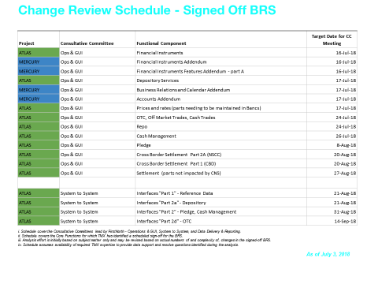

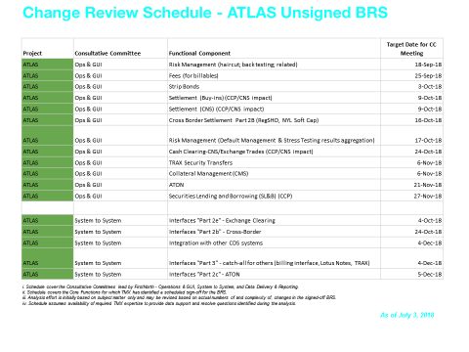

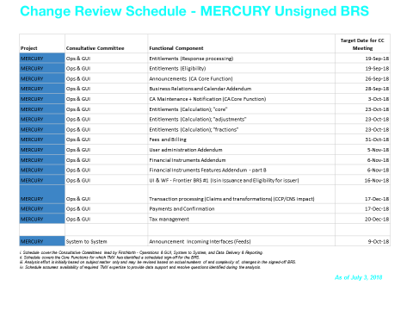

Project Status

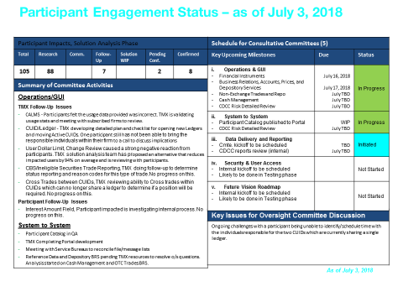

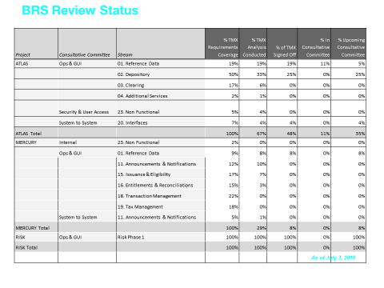

Participant Impact Log

