CCMA
TMX – Post Trade Modernization Project - Advisory Council
(PTMP- AC)
January 17, 2018
Agenda

- CCMA and the TMX Post Trade Modernization Project
  - Role of CCMA
  - Role within the TMX project (Oversight Committee)

- CCMA Advisory Council
  - Role
  - Membership
  - Mandate

- CCMA Funding Model
  - T+2
  - TMX - Post-Trade Modernization Project – Advisory Council

- CCMA Governance
  - CCMA Board Requirement – formal committee members

- For future meetings of the PTMP-AC
  - What information does the industry require?
  - How do we feed information into the Oversight Committee?
  - Meeting frequency?
  - Attendance at the Consultative Committees

- Questions

- Next Meeting February 21, 2018 at 11:00 AM ET

TMX - Participant​ ​Engagement​ ​Committee​ ​Structure

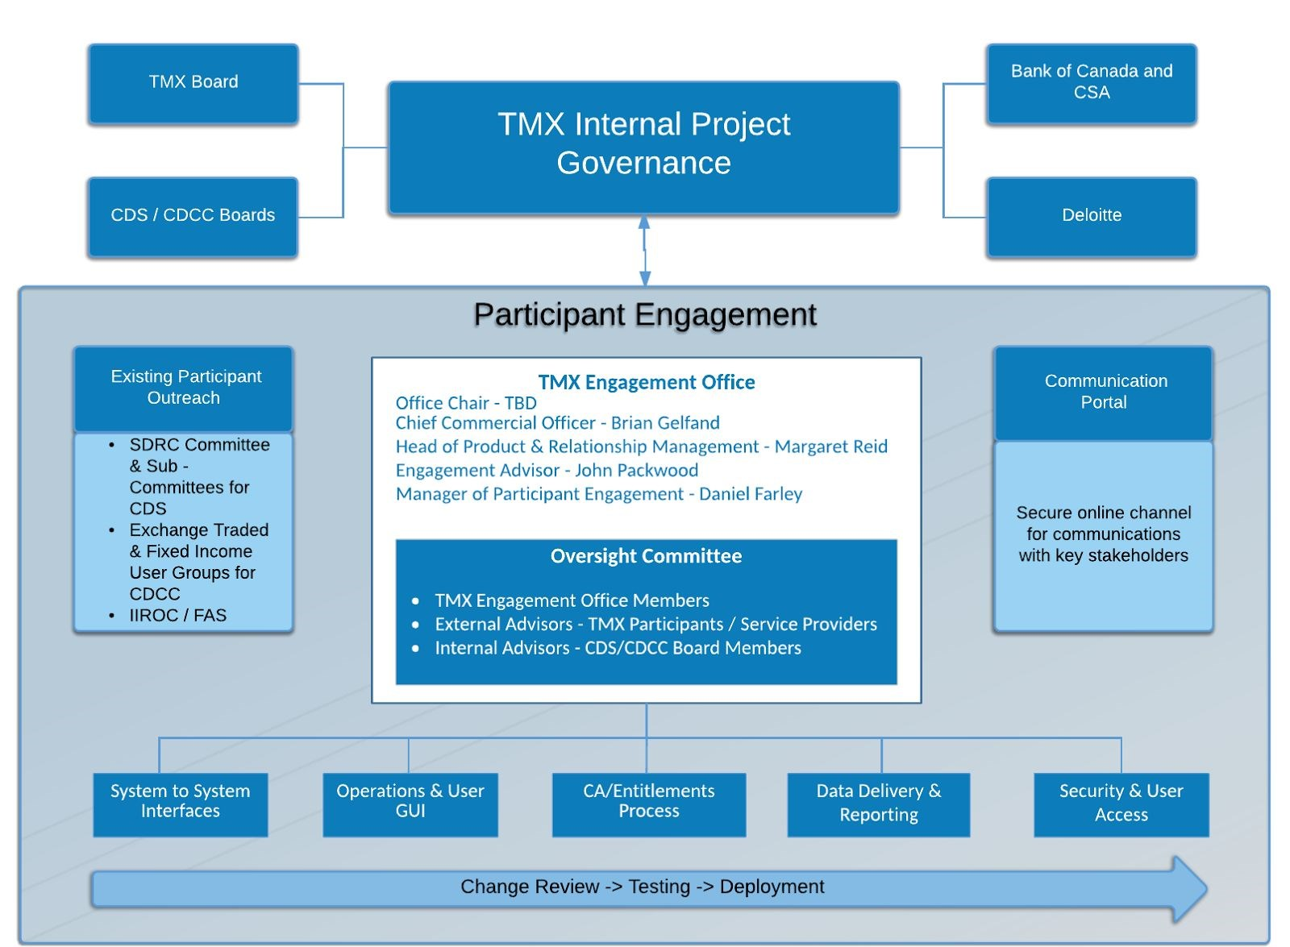
- Note: there are now 7 consultative committees (‘Future Vision Roadmap’ and ‘Risk Functionality and Processes’ have been added).

TMX Post-Trade Modernization Project
Advisory Council Mandate

Overview
The Board of Directors of the Canadian Capital Markets Association (CCMA) has approved a CCMA initiative to support the investment industry in working with the TMX, including CDS and CDCC, to modernize its clearing and settlement systems, as well as its entitlement and corporate action systems. The CCMA is a federally incorporated, not-for-profit organization, launched to identify, analyze and recommend ways to meet the challenges and opportunities facing Canadian and international capital markets
Due to its mandate to communicate, educate and help co-ordinate the investment industry on matters spanning multiple industry segments, the CCMA was chosen to support this important TMX project. These systems are critical to Canadian capital markets because CDS is the hub connecting investment dealers, custodians, exchanges and other parts of Canada’s clearing and settlement infrastructure and, indirectly, the Buyside, including pension plans, fund managers and others. To help ensure a smooth transition to modernized systems, the CCMA is establishing a Post-Trade Modernization Advisory Council.

Composition
The Advisory Council will be co-chaired by the CCMA’s Executive Director (Keith Evans) and Greg Holmes, Vice President, Capital Markets/Wealth Management Operations, at CIBC.
Participation on the CCMA’s TSX/CDS Post-Trade Modernization Advisory Council is open to all CDS participant organizations, their service bureaus, and their vendors. Industry associations, SROs, buy-side firms, consultants, as well as regulators are also welcome to attend as ‘Observers’.

Reporting Structure
The Advisory Council reports to the CCMA Board of Directors via the Executive Director/Co-Chair of the PTMP-AC.
Responsibilities
The terms of reference for the Post-Trade Modernization Advisory Council is to review and provide input to the TMX Post-Trade Modernization Oversight Committee, as well as the consultative work streams, overseeing the Post-Trade Modernization Project. Specifically, Council members will:
- review all material documents related to the project
- identify issues arising in any area of the project that will have a material impact on transaction processing
- assess/propose solution(s) to the above
- gain industry agreement where required
- identify rule changes, if any
- identify procedural changes, if any
- identify vendor changes as a result of changes identified above
- comment on timelines
- coordinate activities to complete tasks the Council identifies
- communicate with, and educate the broader investment community as required.

Governance
Meetings will be called by one of the Co-Chairs. Notices calling meetings and agendas will be sent to all PTMP-AC members/observers. Meetings will be minuted and attendance recorded. Meeting minutes will be tabled with the PTMP-AC for approval. There is no set minimum quorum requirement for meetings. Minutes and decisions of the PTMP-AC may be posted on the CCMA website.

Proposed TMX Post-Trade Modernization Project
Advisory Council Membership List
Broker-Dealers/Banks
Greg Holmes CIBC
Brenda McIntyre Canaccord
Deborah Carlyle BBS
Pierre Mital Casgrain
Sam Farrell Credit Suisse
Nelson Dugre-Sasserville NBC

Custodians
Louis Lesnika CIBC Mellon
Domenic Sgambelluri Northern Trust
Chris Strong RBC Investor Services
Maggie Salisbury Statestreet

Transfer Agents
Donna McLaughlin Computershare

Other
Keith Evans CCMA

January 2018

