T+1 Legal and Regulatory Working Group (T1LRWG)
Agenda
December 17, 2021 at 1:00 PM ET
Chaired by:
Jamie Anderson - CCMA

- Introduction to T+1
  - T+1 Organization in Canada
  - T+1 Steering Committee Mandate
  - T+1 Steering Committee Membership

- T+1 Legal and Regulatory Working Group Mandate

- Initial list of Issues

- Other Business

- Next Meeting January TBD, 2022 at 1:00 PM ET

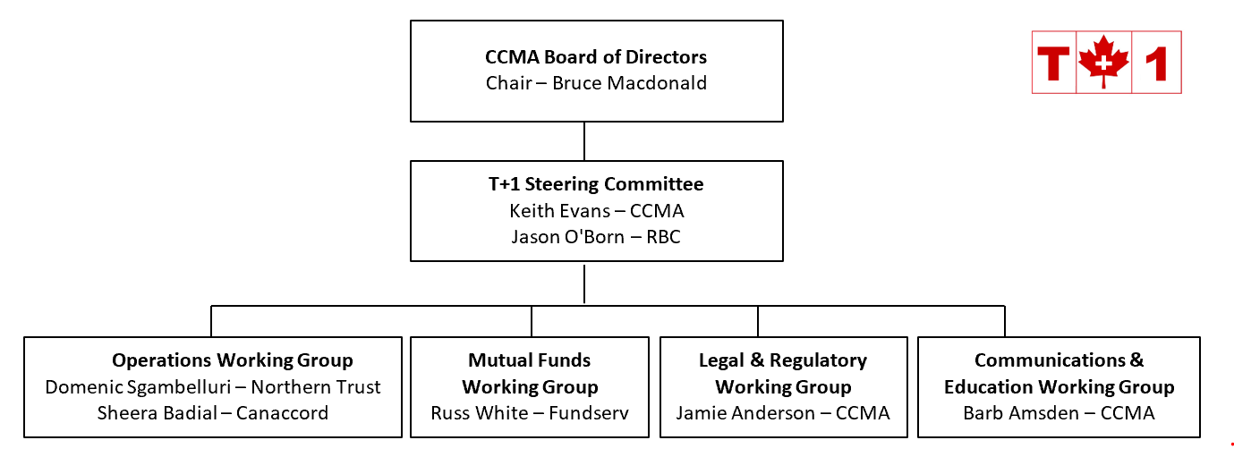

T+1 Steering Committee (T1SC)
Mandate for T+1 Initiative
Overview
The T+1 Steering Committee (“T1SC”) has been mandated to co-ordinate an industry-wide effort to shorten the securities settlement cycle from the current two day period, or T+2, to a one day period, or T+1. The T1SC will identify legal and regulatory changes, systems, processes and procedural changes, and ensure effective communication and education of the overall Canadian financial services industry.

The Canadian T+1 initiative is being coordinated in concert with the United States. The joint Canadian-American implementation date is targeted for Q4 – 2023 to Q2 - 2024.
Composition
The T1SC membership is open to individuals representing firms and organizations with an interest in the T+1 initiative. These firms and organizations include the buy-side, custodians, sell-side, service providers, industry utilities, self-regulatory organizations, and other regulatory bodies.
Reporting Structure
The T1SC reports to the CCMA Board of Directors via the Executive Director/Co-Chair of the T1SC.
Responsibilities
The T1SC will, or will oversee working groups that will:
- identify all areas (system development, procedure, process, etc.) that need to be addressed,
- identify the various solutions to the above,
- gain industry agreement on required standards,
- identify regulatory changes,
- agree on timelines,
- coordinate activities to complete the tasks,
- educate those in need of education,
- be a spokesperson for the T+1 initiative,
- plan the industrywide testing that will be needed to ensure readiness,
- coordinate with the U.S. to ensure a lock-step approach with regards to implementation.

Governance
Meetings will be called by one of the Co-Chairs. Notices calling meetings and agendas will be sent to all T1SC members/observers. Meetings will be minuted and attendance recorded. Meeting minutes will be tabled with the T1SC for approval. There is no set minimum quorum requirement for meetings. Minutes and decisions of the T1SC may be posted on the CCMA website.

Proposed T1SC Membership List
Buy Side
Mark Austin Connor, Clark and Lunn Financial Group
Melissa Ghislanzoni PMAC
Pamela Egger IFIC
TBD TBD
Custodian
Louis Lesnika CIBC Mellon
Domenic Sgambelluri Northern Trust/Co-Chair OWG
John Riordon RBC Investor Services
Denny Mendonca State Street
Sell Side
Keri Peacock BMO
Corey Cunningham Scotiabank
Charlena Gualin CIBC
Stephanie Leblanc-Mchenry Fidelity Clearing
Nelson Dugre-Sasseville National Bank
Jason O’Born RBC Capital Markets/Co-Chair T1SC
Sheera Badial Canaccord/Co-Chair OWG
Rob Candido TD
Other
Barb Amsden CCMA/Chair CEWG
Jamie Anderson CCMA/Chair LRWG
Russ White Fundserv/Chair MFWG
Keith Evans CCMA/Co-Chair T1SC

Legal and Regulatory Working Group
(LRWG)
Mandate for T+1 Initiative

Overview
The Legal and Regulatory Working Group (“LRWG”) has been mandated to identify all legal and regulatory issues related to Canada’s move from a securities settlement period of two days (T+2) to one day (T+1).
The Canadian T+1 initiative is being coordinated in concert with the United States. The joint Canadian-American implementation date is targeted for Q1-2024.
Composition
The LRWG membership is open to individuals representing firms and organizations with an interest in the T+1 initiative. These firms and organizations include the buy-side, custodians, sell-side, service providers, industry utilities, self-regulatory organizations, and regulatory bodies. New members may join the LRWG at any point.
Reporting Structure
The LRWG reports to the CCMA T+1 Steering Committee (“T1SC”) via the LRWG Chair.
Responsibilities
The LRWG will:
- identify, describe and document all legal and regulatory issues related to the move to T+1;
- achieve industry consensus on proposed solutions, action plans and timelines for all open issues;
- assign responsibility for issues;
- provide ongoing communication to the T1SC, tracking issues through to completion; and
- provide additional guidance, direction, and support for T+1 legal and regulatory issues as requested by the T1SC.

Governance
Meetings will be called by the Chair. Notices calling meetings and agendas will be sent to all LRWG members. Meetings will be minuted and attendance recorded. Meeting minutes will be tabled with the LRWG for approval. There is no set minimum quorum requirement for meetings. All recommendations will be forwarded to the T1SC for final approval. Minutes and decisions of the LRWG may be posted on the CCMA website.

