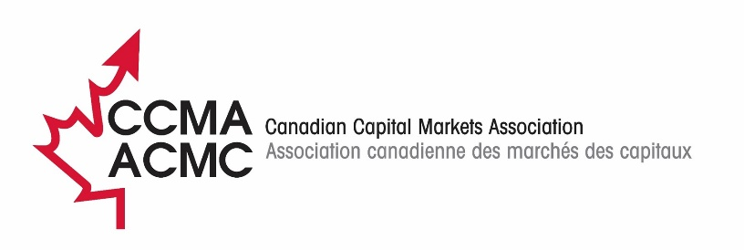

T+1 Communications and Education Working Group (CEWG)

Approved Minutes

Tuesday, March 14, 2023

- Welcome and introductions

Note: See attached list of meeting participants, agreements, and action items.

- Draft minutes of March 14 CEWG Meeting

The draft minutes of the February 14 CEWG meeting were accepted without change. The items identified for action had been completed or were on the day’s agenda, ongoing, or scheduled for the future.

- T+1 news/information

  - Canadian updates
Barb provided the following updates:
- The industry response to the proposed regulatory changes (NI-24-101) was expected to receive T+1 SC approval and be sent on March 17.
- The industry had agreed that the first T+1 trading date in Canada would be May 27, 2024, which was not a holiday, despite the U.S.’s March 28 start date because to complete implementation overnight between the 27th and 28th was too risky; an announcement and FAQs would be circulated.
- The industry continued to await a decision on CDS’s major PTM project, and the absence of a decision was delaying release of the CDS test plan.
- The Buyside Task Force continued to meet, however, the participants all appeared to be highly automated pension and investment managers, meaning less progress than hoped for to date.

  - U.S. update
The U.S. had promised to release for the first time an equivalent to Canada’s T+1 Asset List by the end of the month.

  - International news
David referred to work by the Association of Financial Markets in London (AFME) which had formed a European T+1 Task Force to consider whether to implement a shortened settlement cycle and the timeframe for any potential switch. The Association of Global Custodians also is assessing the impact of T+1. In South America, there is discussion of the possibility of merging the central securities depositories (CSDs) of Brazil, Argentina, and perhaps Peru into a single CSD and one exchange.

  - Events, Etc.
- Barb thanked Yianna and Ali for helping monitor media coverage following the SEC T+1 date announcement and identify any with incorrect information.
- CCMA staff would be meeting with the Canadian Association of Alternative Strategies and Assets (CAASA) on March 14 and the International Swaps and Derivatives Association (ISDA) on March 15.
- There were a number of upcoming events:
  - ValueExchange Canadian Survey Results – March 22, 2 p.m.
  - PIAC – April 13, noon.
  - OSC Dialogue – April 27; the details of how a simple message could be conveyed was under discussion.
  - A Countdown Timer had been added to the CCMA website.
  - LinkedIn was being regularly updated and members were encouraged to ‘like’ or comment to extend T+1’s breadth of reach.

- For review, amendment, approval

- Draft FAQs: Members had been asked to provide any comments on the proposed FAQs circulated with the agenda. No proposed changes had been received.

- For discussion

- March 31 newsletter content: Members agreed that topics should include the SEC’s date decision and its implications for Canada, the NI 24-101 comment letter, the fact that the first T+1 trading date in Canada is May 27, 2024, the ValueExchange survey results and conclusions, and recent FAQs. Pat suggested that a list of select jurisdictions and their settlement cycles be a tool that the newsletter could link to.

- Draft webinar: Members discussed the draft PowerPoint presentation that had been circulated for the PIAC presentation. It later would form the basis of a generic PowerPoint presentation that firms could use to provide background briefings on the T+1 project now that project teams were being set up, staffed, and funded. Members provided comments on the draft that will be reflected in an updated version.

- Other issues as raised

Members briefly discussed the implications of a delay in decision regarding the TMX/CDS PTM project. David Petitville mentioned that the component for partial settlements is only being built after T+1. The U.S. testing start in August 2023 was discussed as a concern if custodians were not ready to support Canadian firms testing with the U.S.

- Next meeting: May 9, 2023

Agreements
Members accepted the draft minutes as written.
Members accepted the draft FAQs as written.
Action Items

# | Description | Who | Status
 | Update webinar with members’ comments at meeting | Barb | Done
 | Draft newsletter and circulate for member comment | Barb/ Members | Done
From preceding meetings
 | Develop a presentation for PIAC | Barb | Done
 | Provide information to CCMA about authoring T+1 article for CIFP | Pat | Underway
 | Follow up with the IIAC for an IIAC member to help co-ordinate communications with the broker-dealers | Barb | Efforts ongoing
 | Extend media outreach once more concrete information is available | CEWG | Discuss in future
 | Help on the Buyside Checklist | Travis | TBD
 | Manage podcast or blog/Qs&As re buyside liquidity issues | Merici | TBD
 | Draft article for ACPM | Barb | Complete
 | Draft article for CIFP | Barb | May 15
 | Prepare an outline/draft generic T+1 presentation | Barb | Underway

Meeting Attendees
Paniz | Ghazanfari | Advocis
Mauro | Lagana | CBA: Canadian Bankers Association
Pat | Dunwoody | CETFA: Canadian ETF Association
Pira | Kumarasamy | IFIC: Investment Funds Institute of Canada
Yianna | Deklaras | National Bank Financial Wealth Management
Annetta | Ho | OSC: Ontario Securities Commission
Ahren | Estabrook | PIAC: Pension Investment Association of Canada/OTPP
David | Petitville | RBC: Royal Bank of Canada Investors Services
Dave | O’Marra | Torstone Technology
Barb | Amsden | CCMA: Canadian Capital Markets Association

